

**Imam Mohammad ibn Saud Islamic University**

**College of Computer and Information Sciences**

**Information Systems Department**

***AI Officer: Automatic License Plate Detection and Recognition (ALPDR)***

**By:**

***Meshari Alqahtani, 441014545, 278, IS***

***Abdulmalik Almonif, 441013517, 278, IS***

**Supervised by:**

***Dr. Waeal J.Obidallah***

Project Submitted in Fulfillment for the IS497/IS495 Course requirements

Third Semester-2023



**Imam Mohammad ibn Saud Islamic University**

**College of Computer and Information Sciences**

**Information Systems Department**

***AI Officer: Automatic License Plate Detection and Recognition (ALPDR)***

**By:**

***Meshari Abdulhadi*  *Alqahtani, 441014545, 278, IS***

***Abdulmalik Abdulaziz Almonif, 441013517, 278, IS***

|  |  |
| --- | --- |
| **Supervisor Name** | ***Dr. Waeal J.Obidallah*** |
| **Date** | 31/05/2023 |
| **Signature** |  |

# Declaration

We Abdulmalik Almonif and Meshari Alqahtani being members of final year project group number 1, declare that this report contains only work completed by members of our group except for information obtained in a legitimate way from literature, company, or university sources. All information from these other sources has been duly referenced and acknowledged in accordance with the University Policy on Plagiarism.

Furthermore, we declare that in completing the project, the individual group members had the following responsibilities and contributed in the following proportions to the final outcomes of the project:

|  |  |  |  |
| --- | --- | --- | --- |
| **Student ID** | **Responsibilities[1]** | **Contribution[2] %** | **Signature** |
| *441014545* | All chapters | 50% |  |
| 441013517 | All chapters | 50% |  |

# Abstract

We present a novel model designed to detect license plates of vehicles involved in violations, such as wanted vehicles or stolen license plates, and promptly alert law enforcement officers. Our solution leverages vehicle details to identify suspicious license plates and provides real-time notifications to police officers via an iPad application connected to their dashcams. By employing artificial intelligence (AI) techniques, our system enables the efficient identification of Saudi license plates, empowering officers with vital information about passing vehicles. In the event of a violation, an alert/notification is generated, enabling police and traffic officers to take immediate action. To achieve this, we employ cutting-edge tools and libraries for machine learning and deep learning and potentially utilize a real dataset or API linked to traffic databases to retrieve accurate vehicle information for training and refining our model.

Input:

* The car's license plate will be captured using advanced Computer Vision techniques, enabling accurate recognition and extraction of the license plate text.

Processes:

* The model will capture an image of the license plate and employ image processing algorithms to extract the text inscribed on the license plate.
* Following the extraction process, the model will cross-reference the vehicle owner's information with the police's database to determine if they are wanted or if the vehicle is reported as stolen.
* If no violation is detected, the model will seamlessly continue capturing license plates of other vehicles.
* In the event of a confirmed violation, whereby the owner is wanted, or the vehicle is reported as stolen based on the police database, an immediate notification will be dispatched to the assigned police officer, ensuring prompt action is taken.

Outputs:

* Ultimately, a comprehensive report detailing the violation, including relevant vehicle and owner information, will be securely sent and stored in the database for future reference and analysis.

# Abstract (in Arabic)

فكرتنا هي نموذج يرصد لوحة المركبات في حال وجود مخالفات مثل (مركبة مطلوبة أو مركبة مسروقة باستخدام بيانات المركبة. وتنبيه الشرطي بالمخالفة التي تم اكتشافها. يمكن القيام بذلك من خلال تطبيق على iPad متصل بكاميرا مثبتة على سيارة الشرطي. سيتمكن ضابط الشرطة من اكتشاف لوح المركبات السعودية باستخدام تقنيات الذكاء الاصطناعي (AI) والحصول على معلومات حول السيارة المارة. في حالة وجود مخالفة، يتم إصدار تنبيه للشرطي من خلال التطبيق لاتخاذ الإجراءات اللازمة. سيتم استخدام بعض الأدوات والمكتبات للتعلم الآلي والتعلم العميق و (احتمال) الحصول على مجموعة بيانات حقيقية من API المرتبطة بقواعد بيانات المرور لاسترداد معلومات المركبات وإدخالها في النموذج.

**المدخلات:**

**لوحة المركبة التي سيتم التقاطها باستخدام تقنيات الرؤية الحاسوبية.**

**العمليات:**

* سيلتقط نموذج الذكاء الاصطناعي صور للوح المركبات ثم سيقوم بمعالجة الصور الملتقطة ليستخرج محتوى اللوحة وما المكتوب فيها.
* بعد عملية استخراج النص من الصور الملتقطة سيرسل النموذج النص لكي يتم التحقق بأن صاحب المركبة ليس مطلوب أمنيًا وأن المركبة ليست مسروقة عن طريق المعلومات المخزنة في قاعدة بيانات الشرطة.
* إذا لم يجد نموذج الذكاء الاصطناعي أيًا من المخالفات المذكورة سيكمل التقاط اللوح إلى أن يتم إيجاد مخالفة.
* أما اذا تم رصد سيارة مسروقة أو سيارة يكون صاحبها مطلوب أمنيًا وتأكد منها عن طريق قاعدة البيانات الخاصة بالشرطة سيتم إرسال إشعار عن طريق التطبيق إلى الشرطي.

**المخرجات:**

**وأخيرًا سيتم إنشاء تقرير ويتم إرساله إلى قاعدة البيانات.**

# Keywords

Artificial Intelligence, Computer Vision, Application Development, Swift Programming Language, Python Programming Language, Image Processing.

# List of Abbreviations

SDLC: Software Development Life Cycle

AI: Artificial Intelligence

WBS: Work Breakdown Structure

BPMN : Business Process Model Notation

LPR: License Plate Recognition

**Table of Contents**

Declaration iii

Abstract iv

Abstract (in Arabic) v

Keywords vi

List of Abbreviations vii

List of Figures ix

List of Tables x

Chapter 1: Planning 1

1.0 Introduction 2

1.1 Project Overview 2

1.2 Problem Statement 2

1.3 Project Impact 3

1.3.1 Local Impact 3

1.3.2 Global Impact 3

1.4 Project Stakeholders 3

1.5 Objectives 3

1.6 Approach 4

1.7 Project Scope 6

1.8 Work Breakdown Structure 6

1.9 Gantt Chart (Time Frame) 7

1.10 Team Member's Responsibilities 8

1.11 Conclusion 9

Chapter 2: Background Analysis 10

2.0 Introduction 11

2.1 Possible Solutions 11

2.2 Overview of Existing systems 12

2.3 Existing Business Processes 13

2.4 Conclusion 13

Chapter 3: Requirements Analysis 14

3.0 Introduction 15

3.1 Requirement Gathering Summary Results 15

**3.1.2 Survey** 15

3.1.2 Brainstorm 16

3.2 Stakeholder Requirements 16

3.3 Proposed Business Process 17

3.4 Functional Requirements 18

3.5 Non-functional Requirements 22

3.6 Conclusion 23

References 24

Appendix 25

A. Miscellaneous 26

B. Presentation Slides 27

# List of Figures

Figure 1: SDLC approach 4

Figure 2: WBS 6

Figure 3 Gantt Chart 1 7

Figure 4 Gantt Chart 2 7

Figure 5 Team Member's Responsibilities 8

Figure 6 Existing Business Processes 13

Figure 7 Survey 15

Figure 8 Proposed Business Process 17

Figure 9 Use Case 18

# List of Tables

Table 1: Planning Phase 4

Table 2: Analysis Phase 5

Table 3: Design Phase 5

Table 4: Implementation Phase 5

Table 5 Comparison between Pole mounted camera and Police dashcam 11

Table 6 Detect License Plate Use-Case description 19

Table 7 Retrieve Vehicle Information Use-Case description 19

Table 8 Violation Detection Use-Case description 20

Table 9 Notification Alert Use-Case description 20

Table 10 Create Report Use-Case description 21

Table 11 History Use-Case description 21

# Chapter 1: Planning

## 

## 1.0 Introduction

In this chapter we will discuss the project overview, define the problem we need to solve, who will get involved, impact and objectives, we will determine the approach team members will use, we will plan for the project timeline and responsibility.

## 1.1 Project Overview

One of the most prominent features of the Kingdom of Saudi Arabia is security and safety. Considering the government automation services and the government's purpose in digital transformation of the Kingdom's Vision 2030. So, our project helps the police to carry out their duty and involve the technology so our model will be noticing the violating vehicles that the police officer does not notice .[1], [2]

## 1.2 Problem Statement

One of the Police problems is that the police officer is not going to drive to a specific location unless any violation appears or issue or a special case has been detected and another police is reporting about the case. Most of the time the police will drive across the city waiting for other police to report a case. At the same time maybe a wanted person/stolen vehicle is driving side by side with the police and the police will not notice that, by developing an AI model that detects the licence plates will be more effective and less of human error.

## 

## 1.3 Project Impact

The outcome of this project will help the police officers to detect those violators quickly and easily.

### 1.3.1 Local Impact

Our project helps the police officer to carry out his duty and involve technology in it, so that our model detecting the violating vehicles that the police officer does not notice and Increase safety and secure environment in Saudi Arabia.

### 1.3.2 Global Impact

At the global level, Saudi Arabia has always been a pioneer in traffic and security development, which we hope our project will be part of that development and we want to bring the AI culture into the governance of all countries to decrease the crime rate worldwide.

## 1.4 Project Stakeholders

* **Police Officer:** The main user/stakeholder is the police officer, since he is the one that will use our application during his driving into the streets for unfold wanted or violated citizens.
* **The Police:** The police departmenthas data of each citizen that has a crime record (Report/wanted citizen or vehicle) will be get from the police departmentdatabase.

## 1.5 Objectives

* Considering 2030 vision of the digital transformation.
* Helps the police officer to detect violated vehicles.
* Capturing the violators who are difficult to verify/detect without the system.

## 1.6 Approach

We chose SDLC approach and waterfall model methodology [3] since we will be working on our project for two semesters, we decided to divide the work into two stages:

* GP1 stage will include Planning and Analysis.
* GP2 stage will include Design and Implementation.

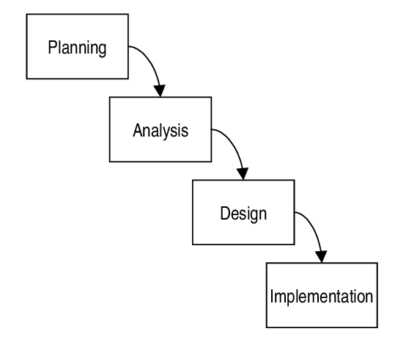

Figure 1: SDLC approach

|  |  |
| --- | --- |
| Phase Name | Planning |
| Definition | The planning phase is the first phase in identifying why an  information system needs to be constructed and how the project team will plan for the system. |
| Deliverables | * Project overview * Problem statement * Project impact * Project stakeholders * Objectives * Approach * Project scope * WBS * Gantt chart * Team's members responsibilities |

Table 1: Planning Phase

|  |  |
| --- | --- |
| Phase Name | Analysis |
| Definition | During the analysis phase, questions regarding who will use the system, what it will do, where and when it will be used, are all addressed. |
| Deliverables | * Possible Solutions * Overview of Existing systems * Existing Business Processes * Requirement Gathering Summary Results * Business Requirements * Proposed Business Process * Functional Requirements * Non-functional Requirements |

Table 2: Analysis Phase

|  |  |
| --- | --- |
| Phase Name | Design |
| Definition | The system's hardware, software, and network architecture, including the user interface, forms, and reports, specific programs, databases, and files needed, are all determined during the design phase. |
| Deliverables | * System modelling * Data modelling * Detailed interface design |

Table 3: Design Phase

|  |  |
| --- | --- |
| Phase Name | Implementation |
| Definition | The implementation phase (or purchase, in the case of a packaged software design) refers to the time when the system is created. Because it takes up the most time and money in the development of most systems, the implementation phase receives the most effort. |
| Deliverables | * System Specification * System Testing * System Deployment |

Table 4: Implementation Phase

## 1.7 Project Scope

The main scope of the project is to make an application that can detect a violated license plate and there are some functionalities.

These functionalities include:

* Simple user interface and navigation.
* Details of the vehicle's owner.
* High accuracy detection of license plates.
* Good security.
* High quality and quick notification sending for alerts and warning of detecting a wanted vehicle.

## 1.8 Work Breakdown Structure

Work Breakdown Structure (WBS) is a hierarchical decomposition of a project or deliverable into smaller, more manageable components. It helps to organize and define the scope of work required to complete a project [4].

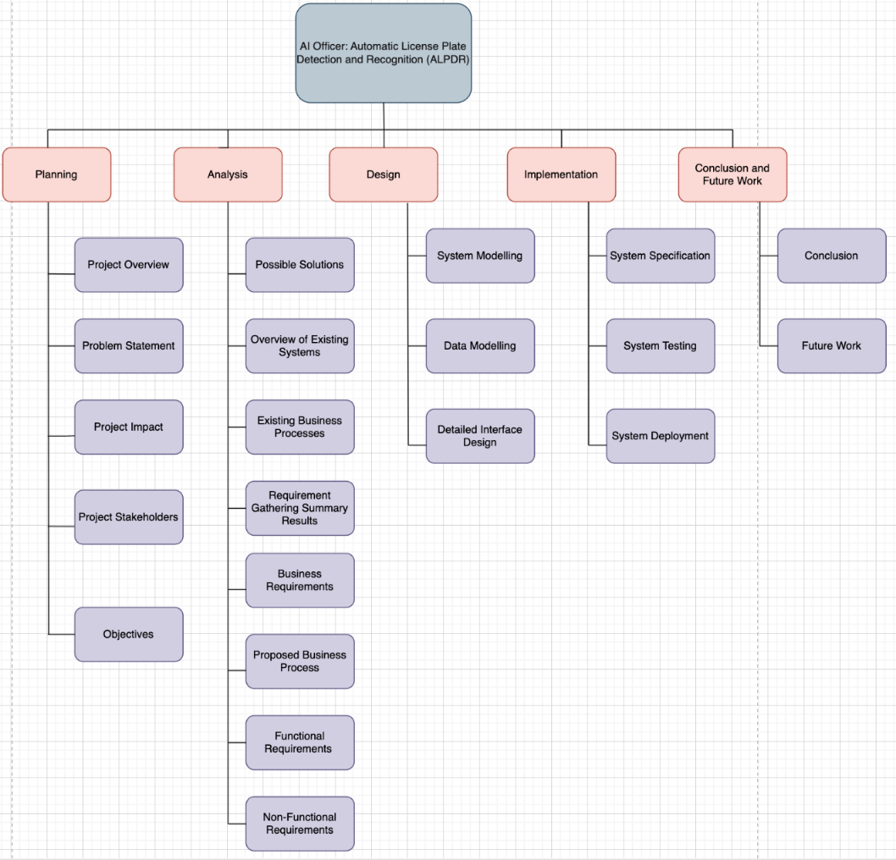

Figure 2: WBS

## 1.9 Gantt Chart (Time Frame)

Gantt chart is a project management tool that illustrates work completed over a period in relation to the time planned for the work. It typically includes two sections: the left side outlines a list of tasks, while the right side has a timeline with schedule bars that visualize work [4].

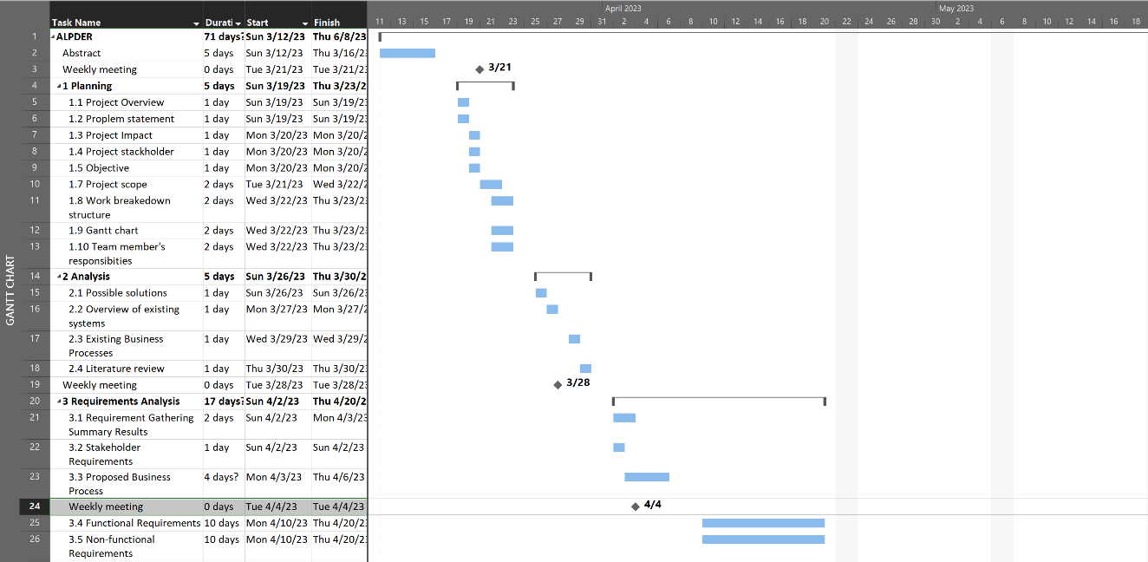

Figure 3 Gantt Chart 1

Figure 4 Gantt Chart 2

## 1.10 Team Member's Responsibilities

The task distributed between team members as responsibility for each member that he is responsible for this task and the other member help him with it.

The responsibilities assigned members perfume as: responsible, participate and both responsible.

Figure 5 Team Member's Responsibilities

## 1.11 Conclusion

We discussed the idea of this project and defined the problem we need to solve, we defined the stakeholders involved and determined the project objectives and impact locally and globally, We will determine the approach team members will staked to, We determined the plan for project time line and distributed the responsibility between team members.

# 

# Chapter 2: Background Analysis

## 

## 2.0 Introduction

In this chapter we will discuss the possible solutions and similar system preferred solution for detection the violations.

## 2.1 Possible Solutions

Our project has two possible solutions for increasing the security and safety, The first one is:

* **Pole Mounted Camera:** it will be a very good solution except for the time because if the vehicle has been detected it will take time to the police car to come to the location, hence it will not be an ideal solution for the problem.
* **Police Dashcam**: Our solution it might be a little bit costly, but it will be efficient since the police will be already at the location that has been detected and will execute the necessary action at the same time, also our solution support non-accessible locations since the dashcam will be already attached to the police vehicle.

|  |  |  |  |  |
| --- | --- | --- | --- | --- |
|  | Cost | Complexity | Efficiency | Time |
| Pole mounted camera | Medium | Medium | Low | High |
| Police dashcam | Medium | Low | High | Low |

Table 5 Comparison between Pole mounted camera and Police dashcam

## 2.2 Overview of Existing systems

The License Plate Recognition System (LPR) is an integral component of the Saher System. It is designed to identify vehicles at city's street, entrances and exits, serving multiple purposes such as statistical analysis, control of stolen or wanted vehicles, and traffic regulation enforcement. The LPR system relies on capturing images of license plates and utilizing advanced algorithms to extract relevant information [5].

**Advantages:**

* Vehicle Identification: LPR allows for automatic identification of vehicles by capturing and processing license plate information. This helps in various applications, including monitoring traffic flow, detecting traffic violations, and managing entry and exit points.
* Stolen Vehicle Detection: By comparing captured license plate information with a database of stolen vehicles, LPR enables the identification of stolen or wanted vehicles. This enhances public safety and aids in the recovery of stolen assets.
* Traffic Regulation Enforcement: LPR plays a crucial role in enforcing traffic regulations by automatically detecting violations such as using mobile, not wearing a seat belt. This helps reduce the reliance on manual enforcement, leading to increased efficiency and consistent application of traffic laws.

**Disadvantages:**

* Not catching the criminal immediately: The criminal can escape while police officer informed and arrive to the position.
* Recognition Accuracy: The effectiveness of LPR is heavily dependent on the accuracy of license plate recognition. Factors such as plate quality, angle, and speed of passing vehicles can impact the system's ability to accurately capture and interpret license plate information. Inaccurate recognition may lead to false positives or negatives, affecting the reliability of enforcement actions.
* License Plate Variations: License plates can exhibit variations in design, font, and layout across different regions or countries. The LPR system needs to account for these variations and ensure compatibility to accurately recognize and process license plate information from diverse sources.

So, Saher system is advance modern system it's helpful to evaluate and learn from those advantages and disadvantages.

## 2.3 Existing Business Processes

BPMN diagram represents the current business process for the saher LPR system based on the provided information. It assumes a simplified representation and may not include all the intricacies and variations of the actual system.

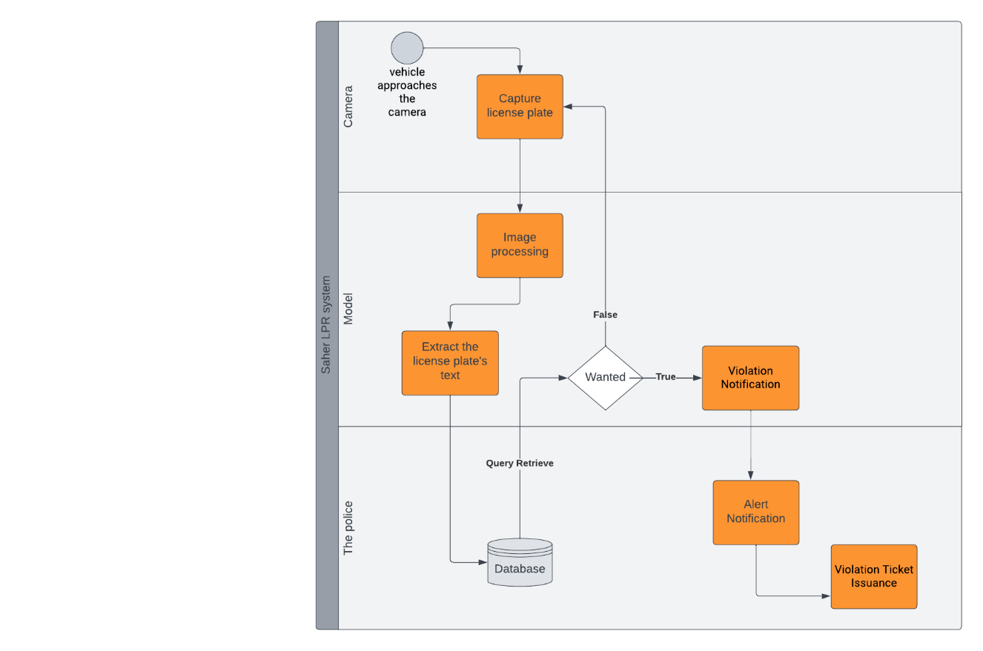

Figure 6 Existing Business Processes

## 

## 2.4 Conclusion

We compared our idea with Saher LPR system's idea and discussed what are the functionalities that Saher LPR System can do/detect. And how our project's purpose is different since we are aiming on the capture the wanted people in the moment and stolen cars, but both systems has a common goal which making life safer and better.

# Chapter 3: Requirements Analysis

## 3.0 Introduction

In this chapter we will discuss the techniques for gathering the requirements to be able to discover the user's needs and satisfy the users in terms of features and the importance of the system and weather the problem that our system is trying to solve is a good solution or not , Also we will design the Business Process and the use-case diagram followed with the functional/non-functional requirements.

## 3.1 Requirement Gathering Summary Results

**3.1.2 Survey**

We used a survey technique in our project and the result we gathered shows in Figure 7 that many of the stolen cars were not found [6].

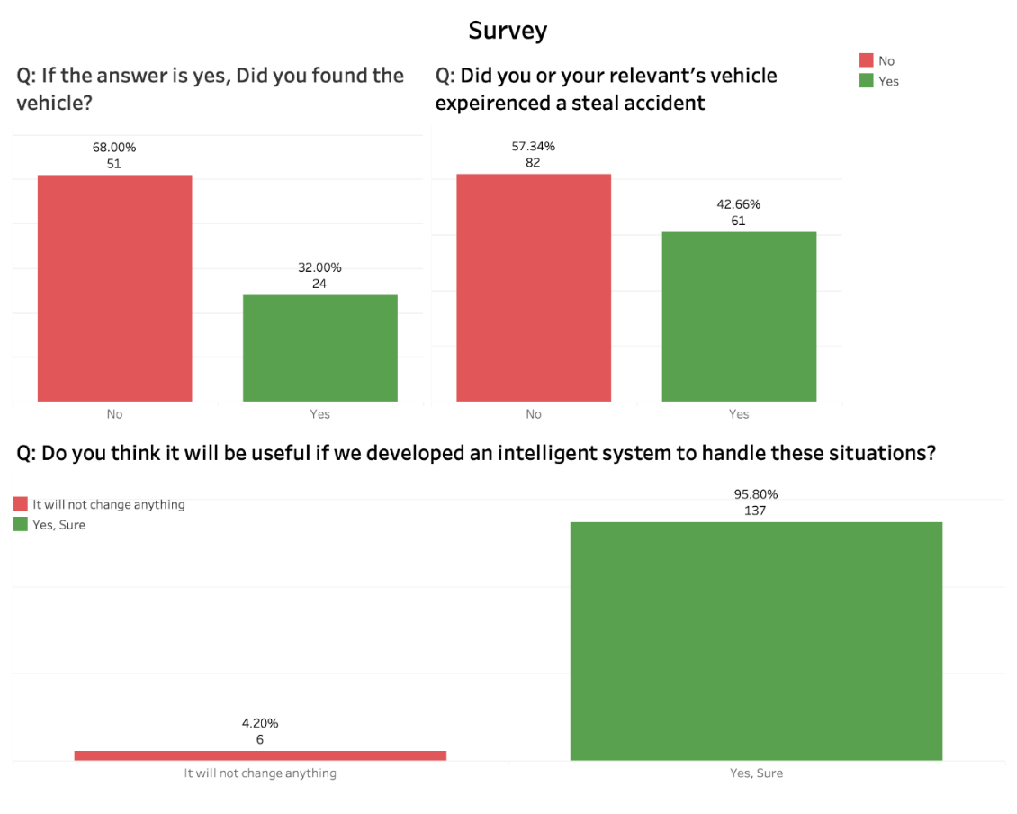

Figure 7 Survey

### 3.1.2 Brainstorm

* + - The system must be efficient when officers use it.
    - The system must send a notification if there is a violated vehicle.
    - The system must be accurate.
    - The dashcam must detects the license plates correctly.
    - The system should retrieve the violator's information correctly.
    - The Interface should be friendly and easy to use.
    - The system must be secure.
    - There should be a history category for previous violations.

## 3.2 Stakeholder Requirements

1. **Police Officer**

* The system should be easy to use and accessible through an iPad connected to the dashcam.
* The system should be able to detect license plates of Saudi cars accurately and quickly.
* The system should be able to compare the license plate information with the police database to check for any violations or crimes associated with the vehicle or driver.
* The system should be able to alert the police officer if there is a violation or a wanted vehicle is detected.
* The system should provide real-time updates on the status of the vehicle's license plate.

1. **The Police Department**

* The system should be able to retrieve data from the police database to cross-check with the license plate information.
* The system should be able to store the license plate and vehicle information in the police database if a violation or a wanted vehicle is detected.

## 3.3 Proposed Business Process

BPMN stands for Business Process Model and Notation. It is a standardized graphical notation used for modelling business processes. BPMN provides a visual representation of the steps, activities, events, and decision points involved in a business process. It allows stakeholders to understand, analyse, and communicate business processes in a clear and standardized manner [7].

Figure 8 shows the BPMN The police officer Lunch the application in the iPad link with the dashcam, the model extracts the text from the plate and retrieve the car's information than check if the car violated or not if yes the model shows notification alert in the application with the information that the officer need.

Top of Form

Bottom of Form

Figure 8 Proposed Business Process

## 3.4 Functional Requirements

The Use-case diagram includes actors, use cases, subject boundaries, and a set of relationships among actors, actors and use cases. These relationships con- sist of association, include, extend, and generalization relationships. Each of these elements is described next [8].

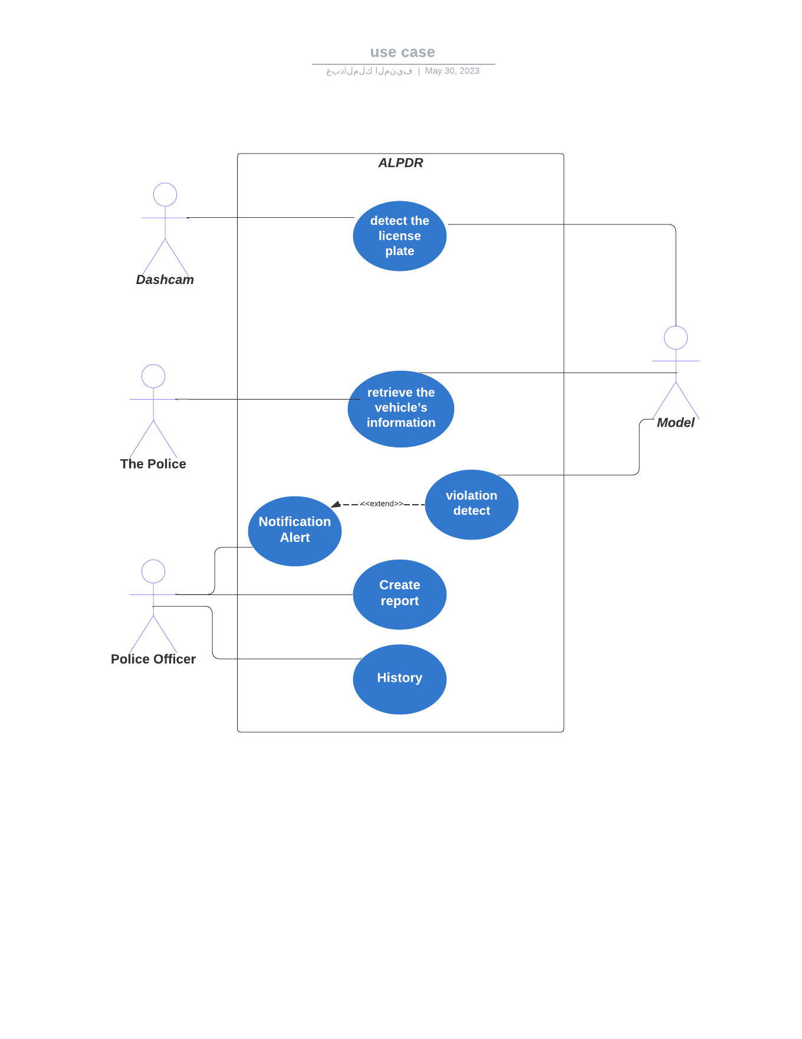

Figure 9 Use Case

Bottom of Form

Table 6 Detect License Plate Use-Case description

|  |  |  |
| --- | --- | --- |
| **Use Case:** Detect License Plate | **ID:** 1 | **Important Level:** High |
| **Primary Actors:** Model, Dashcam | | |
| **Brief Description:** The model detects the license plate of a passing vehicle by dashcam using computer vision techniques. | | |
| **Preconditions:** Dashcam is installed and properly working. | | |
| **Relationship:**  **Association :** Model, Dashcam  **Include :**  **Extend :**  **Generalization :** | | |
| **Flow Of Event:**   1. Dashcam captures an image of a passing vehicle. 2. Model processes the image using computer vision techniques to detect the license plate. 3. Model extracts the license plate information from the detected license plate. 4. License plate keywords is passed to the next use-case. | | |
| **Postconditions:** License plate is successfully detected and passed to the next use-case. | | |

|  |  |  |
| --- | --- | --- |
| **Use Case:** Retrieve Vehicle Information | **ID:** 2 | **Important Level:** High |
| **Primary Actors:** Model, The Police | | |
| **Brief Description:** The model retrieves information about the passing vehicle from the police databases. | | |
| **Preconditions:** License plate is detected in the previous use-case. | | |
| **Relationship:**  **Association :** Model, The Police  **Include :**  **Extend :**  **Generalization :** | | |
| **Flow Of Event:**   1. Model sends a request to the police databases, providing the detected license plate information. 2. The Police retrieve the vehicle information associated with the provided license plate. 3. The Police return the vehicle information to the Model. 4. Vehicle information is received and stored for further processing. Postconditions: Vehicle information is successfully retrieved and stored for further processing. | | |
| **Postconditions:** Vehicle information is successfully retrieved and stored for further processing. | | |

Table 7 Retrieve Vehicle Information Use-Case description

|  |  |  |
| --- | --- | --- |
| **Use Case:** Violation Detection | **ID:** 3 | **Important Level:** High |
| **Primary Actors:** Model | | |
| **Brief Description:** The model checks if any violation is related to the license plate or vehicle information. | | |
| **Preconditions:** Violation or issue is detected in the previous use-case. | | |
| **Relationship:**  **Association :** Model  **Include :**  **Extend :**  **Generalization :** | | |
| **Flow Of Event:**   1. Model analyzes the license plate and vehicle information to identify any violations. 2. If a violation is detected, an alert/notification is generated. 3. The Model sends the alert/notification to the Police Officer. | | |
| **Postconditions:** An alert/notification is sent to the Police Officer if a violation is detected. | | |

Table 8 Violation Detection Use-Case description

|  |  |  |
| --- | --- | --- |
| **Use Case:** Notification Alert | **ID:** 4 | **Important Level:** High |
| **Primary Actors:** Model, Police Officer | | |
| **Brief Description:** The model alerts the Police Officer of any violation or issue related to the license plate or vehicle information. | | |
| **Preconditions:** Violation is detected in the previous use-case. | | |
| **Relationship:**  **Association :** Model, Police Officer  **Include :**  **Extend :** Violation Detection  **Generalization :** | | |
| **Flow Of Event:**   1. Model generates an alert/notification indicating the violation or issue. 2. The Model sends the alert/notification to the Police Officer. 3. Police Officer receives the alert/notification and takes necessary actions. | | |
| **Postconditions:** Police Officer is alerted and takes necessary actions based on the violation or issue detected. | | |

Table 9 Notification Alert Use-Case description

|  |  |  |
| --- | --- | --- |
| **Use Case:** Create Report | **ID:** 5 | **Important Level:** High |
| **Primary Actors:** Police Officer | | |
| **Brief Description:** The Police Officer writes a report about a violation. | | |
| **Preconditions:** Notification is sent in the previous use-case. | | |
| **Relationship:**  **Association :** Police Officer  **Include :**  **Extend :**  **Generalization :** | | |
| **Flow Of Event:**   1. Police Officer accesses the system's report creation functionality. 2. Police Officer provides the necessary details and information to create the report. 3. The report is created and saved in the system. | | |
| **Postconditions:** A report is successfully created by the Police Officer. | | |

Table 10 Create Report Use-Case description

|  |  |  |
| --- | --- | --- |
| **Use Case:** History | **ID:** 6 | **Important Level:** High |
| **Primary Actors:** Police Officer | | |
| **Brief Description:** The Police Officer views previous violations information and reports. | | |
| **Preconditions:** Violations are created in the previous use-cases. | | |
| **Relationship:**  **Association :** Police Officer  **Include :**  **Extend :**  **Generalization :** | | |
| **Flow Of Event:**   1. Police Officer accesses the system's history feature. 2. Police Officer selects the option to view previous violations. 3. The system retrieves and displays the information and reports of previous violations. | | |
| **Postconditions:** Previous violations information and reports are successfully displayed to the Police Officer. | | |

Table 11 History Use-Case description

## 3.5 Non-functional Requirements

Non-functional requirements, also known as quality attributes or system qualities, describe the characteristics and constraints that define how a system should perform rather than what it should do. They focus on aspects such as performance, security, reliability, usability, maintainability, and scalability [9].

1. **Response time:** The system should be able to process and analyze the license plate information quickly and efficiently to provide timely alerts to the traffic officers in case of any violations.
2. **Accuracy:** The system should be accurate in detecting license plate information and matching it with the database to ensure that false alarms are minimized.
3. **Compatibility:** The system should be compatible with different types of dashcams, and mobile devices used by traffic officers.
4. **Security:** The system should ensure the security of the license plate information and personal data of citizens by implementing appropriate security measures.
5. **Usability:** The system should be easy to use and user-friendly for the traffic officers to be able to operate it without extensive training.
6. **Sustainability:** The system should be designed to be environmentally friendly, and any hardware used should be energy-efficient and recyclable.
7. **Scalability:** The system should be able to scale up to accommodate an increasing number of license plates and data in the future.
8. **Reliability:** The system should be reliable and available 24/7 to ensure that any violations are detected in real-time.
9. **Accessibility:** The system should be accessible to all traffic officers regardless of their physical abilities and should adhere to accessibility guidelines.

## 3.6 Conclusion

We discussed in this chapter the importance of our system and the survey is representation of the user acceptance of the idea and the users thinks that involving the AI is a powerful and impactful solution to have as a Saudi citizens. Also we discussed the partners involved in this project and the functional/non-functional requirements needed to develop this AI product.

# References

[1] Saudi Arabian General Investment Authority (SAGIA), *Saudi Arabia: Ensuring Security and Safety*.

[2] Stéphane Lacroix, *Saudi Arabia’s Security Challenges and Transformation*. 2018.

[3] Simplilearn, *Software Development Life Cycle (SDLC)*.

[4] Project Management Institute (PMI)., *A Guide to the Project Management Body of Knowledge (PMBOK® Guide)*.

[5] General Department of Traffic Ministry of Interior, "Saher LPR System." https://www.moi.gov.sa/wps/portal/Home/sectors/publicsecurity/traffic/contents/!ut/p/z1/pVNdT8IwFP0rvvBI7m331T1WhuuESAaOsb6YMjapugFzAf33DmNMRGEY7lObnHvuPaenIGEGslRb_ahqvSrVS3NPpP2AgWkKYtKB74UW8nDQHwWeQbGPEH8C3NDvCbEHEG4jDxw6wsAifkBBntP_DUDObpBzYyqEE9LR4Mz (accessed May 29, 2023).

[6] "Survey." https://docs.google.com/spreadsheets/d/1WVhzbXzQ43QSmEr5dABXbUc94vdo5KCxHsYtxNtRPlk/edit?usp=sharing (accessed May 29, 2023).

[7] Bruce Silver, *BPMN Method and Style*.

[8] B. H. D. T. Alan Dennis, *System Analysis Design UML Version 2.0 AN OBJECT-ORIENTED APPROACH*.

[9] Karl Wiegers and Joy Beatty, *Software Requirements*.

# Appendix

[All appendix items shown here must be included]

# A. Miscellaneous

[Includes any further data (for example: interview form, questionnaire form, Interview answers, questionnaire responses, mock interface, remaining figures of data analysis …etc.)]

# B. Presentation Slides

[4 slides per page]

1. Write down your responsibilities in the project.
2. Must add to 100%